Coding project :

a. The analytical solution is included in the final page of this pdf.

b. For the mesh size of 0.05, with K = 2, the numerical solution for u(x) was computed using Gauss Order 3. The results are shown below:

|  |  |
| --- | --- |
| Node coordinates | Nodal Solutions |
| 0 | 0 |
| 0.05 | 0.110854 |
| 0.1 | 0.209824 |
| 0.15 | 0.282319 |
| 0.2 | 0.326129 |
| 0.25 | 0.351646 |
| 0.3 | 0.377113 |
| 0.35 | 0.420794 |
| 0.4 | 0.493138 |
| 0.45 | 0.592001 |
| 0.5 | 0.702848 |
| 0.55 | 0.803891 |
| 0.6 | 0.874273 |
| 0.65 | 0.902155 |
| 0.7 | 0.889636 |
| 0.75 | 0.852575 |
| 0.8 | 0.815316 |
| 0.85 | 0.802275 |
| 0.9 | 0.829488 |
| 0.95 | 0.89928 |
| 1 | 1 |

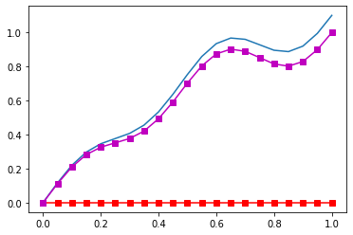

The sum of error computed using the exact solution and the numerical solution for this case for the given solution was 1.055292 .

c) For the different k values, the sum of error as a function of mesh size have been reported below:

|  |  |  |  |  |  |
| --- | --- | --- | --- | --- | --- |
|  | **Sum of Absolute Errors** | | | | |
| **Mesh Size** | **K = 2** | **K = 4** | **K = 8** | **K = 16** | **K = 32** |
| 0.01 | 5.07580053 | 5.025649 | 4.942662 | 4.781237 | 4.463883 |
| 0.025 | 2.060597036 | 2.040671 | 2.007523 | 1.943311 | 2.020504 |
| 0.04 | 1.305756683 | 1.294434 | 1.273786 | 1.236529 | 1.691531 |
| 0.05 | 1.055292 | 1.045692 | 1.029252 | 1.086744 | 11.36046 |
| 0.075 | 0.703755506 | 0.697467 | 0.687471 | 0.725085 | 1.36156 |
| 0.5 | 0.151654712 | 0.138726 | 4.349043 | 1.082095 | 135.3575 |

1. Analytical solution for the problem is as follows:

